Press release

NEW STUDY RESULTS FROM UNIVERSITIES OF MILAN AND SIENA

Aadva Lab Scan found to have highest accuracy

Leuven, Belgium (June 14th, 2017): Dental technicians who consider stepping into a digital workflow no longer need to worry.

A new study shows that the accuracy of Aadva Lab Scan from GC surpasses the accepted boundaries. With the reliability of the digital workflow now much improved, lab technicians can rely on this advanced technology while the risk of manual errors being made during this step belongs in the past.

Researchers from the universities of Milan and Siena have tested the trueness and precision of seven extraoral laboratory scanners. The results of this study were published in the Journal of Prosthetic Research in October 2016.

Study results

A sand-blasted titanium reference model was scanned with an industrial 3D scanner to obtain a reference digital model. Then, the same reference model was scanned 10 times with each tested scanner. By comparing the scans with the reference digital model from the industrial scanner, the trueness of the scans could be determined. All the scans were exported in .stl format and compared using dedicated 3D software. The precision was evaluated by comparing the 10 scans from each scanner with each other. The accuracy is determined by both trueness and precision.

Aadva Lab Scan showed the fewest discrepancies in comparison to the reference model (root mean square of 7,7 µm) and between scans (standard deviation of 4,0 µm), which determine trueness and precision, respectively.
Both trueness and precision were best with GC’s Aadva Lab Scan, being significantly better than five out of seven tested laboratory scanners. These results are far below the accepted level of discrepancy of 50– 75 µm. However, any improvement in accuracy will benefit the final fit of the restoration since this is merely the first step of the manufacturing process.

Fast scans at the highest accuracy

The high accuracy and the step-by-step of workflow options provided do not come at the expense of speed; with a scan time of 980 milliseconds, the Aadva Lab Scan is one of the fastest dental scanners available. It is a highly versatile and user-friendly open system, which opens up a lot of possibilities with regard to materials, techniques and indications.

Patented scan flags

Aadva Lab Scan makes use of innovative patented scan flags, resulting from continuous efforts from our Research and Development team in Japan. These scans flags have a unique coding system consisting of four fixed and one moving laser-engraved point on the body. This has the advantage that the implant brand, diameter and position are automatically retrieved within seconds and with the highest accuracy and immediately transferred to the digital model. This technique eliminates the need for multiple scans, saving up to 20 seconds per implant, and eliminating the matching with a scan body library by the user itself that is needed when working with classical scan bodies.

A good fit starts with an accurate model

As the authors already stipulated, working with highly accurate models is mandatory to manufacture restorations with an optimal fit. It is the first step in the manufacturing process, and we share the thought that starting with the highest accuracy possible is the best guarantee for delivering high-quality work.

More information about Aadva Lab Scan is available at www.gceurope.com.

References:
Adapted from: Mandelli et al. Evaluation of the accuracy of extraoral laboratory scanners with a single-tooth abutment model: A 3D analysis. J Prosthodont Res. 2016 Oct 19. pii: S1883-1958(16)30091-3.”

Representation of the three-dimensional comparison between the digital reference model and the model created by each scanner. Green color represented the most accurate areas, followed by yellow and light blue. The GC Aadva Lab Scan shows the best accuracy among the several scanners tested in this study.

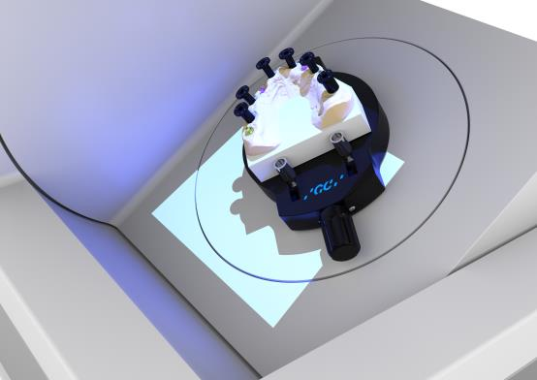
Gypsum model with Scanflags

Contact:
GC Europe N.V.
Head Office
Interleuvenlaan 33
3001 Leuven
BELGIUM

