Press Release

Simple to use yet long-lasting

G-BOND™ proven to be equally successful as gold standard three-step adhesive in the long term.

Randomised clinical trials are the ultimate proof of the performance of dental materials. However, it takes a lot of time and effort to collect these data. When longer periods are considered, clinical data are scarce. A recently published study¹ from the University of Leuven demonstrated that G-BOND (GC) and Optibond FL (Kerr) performed equally successful after 9 years of clinical function. This result shows that the simplified adhesive approach with G-BOND is reliable on the long term.

Durability is an important aspect of contemporary dentistry, especially since an often heard criticism is that replacement of restorations accounts for a considerable part of the expenses. Obtaining a good adhesion is crucial for durability, since it prevents restoration loss, marginal infiltration and consequent secondary caries. In this study, the performance of the one-step self-etch adhesive G-BOND was compared with the three-step etch-and-rinse adhesive Optibond FL, that is often considered as the gold standard. In total, 267 lesions were included and randomly treated with either G-BOND or with Optibond FL. A similar retention rate of 89.7% was recorded for both adhesives and the overall clinical success rates were 80.3% and 79.5% for G-BOND and Optibond FL, respectively. The HEMA-free formula of G-BOND is part of its success; by omitting this hydrophilic monomer, the long-term hydrolytic stability is improved.
For G-ænial BOND and G-Premio BOND, the successors of G-BOND, the same HEMA-free principle was adopted, but the formulas have been further optimised for even more flexibility.
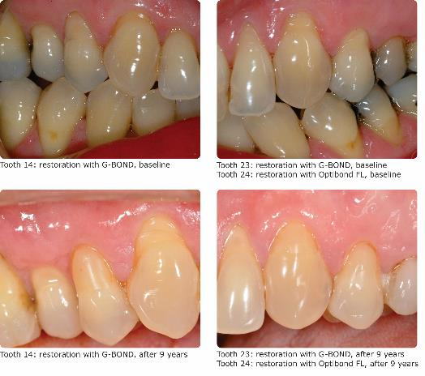

More information from GC
• GC website with information on the company and products:
https://www.gceurope.com/

• YouTube channel with practical tips and tricks in dentistry:
https://www.youtube.com/user/GCEuropeProducts/featured

¹Peumans M, Wouters L, De Munck J, Van Meerbeek B, Van Landuyt K.
Nine-year clinical performance of a HEMA-free one-step self-etch adhesive in noncarious cervical lesions. J Adhes Dent, 2018;20(3):195-203. doi: 10.3290/j.jad.a40630.

GC Europe N.V.
Interleuvenlaan 33
3001 Leuven
Fon +32.16.74.10.00
Fax +32.16.74.11.99
www.gceurope.com
marketing@gc.dental

