Press Release

Research collaboration that stimulates quality and innovation

INTOA! - business entrepreneurship first prize for collaboration between the University of Turku and Stick Tech - GC

One of the objectives of the university is to encourage scientists to commercialise their research results. One way to do so is the annual INTOA! - business entrepreneurship prize. This year’s shared first prize was awarded to the Turku Clinical Biomaterials Center (TCBC) – Stick Tech research collaboration, shared with the Center for Learning Analytical Research.

For the academic year 2017-2018, a prize of 10.000€ was awarded to the TCBC – Stick Tech research collaboration. This is a strong signal from the University of Turku that the collaboration with Stick Tech - GC is highly appreciated. This collaboration has enabled the establishment of a framework for the research related to fibre technology with a focus on dental care.
Recent developments have yielded a new type of fibre post with a semi-IPN (interpenetrating polymer network) polymer matrix, commercialised in Japan as MI Core Fibre Post (GC). The properties of this post resemble those of dentine very closely, making it a very suitable replacement material fitting in the concept of minimally invasive dentistry.
The fibre-reinforced composite everX Posterior™ (GC) is another example that arose from this collaboration. This product has already received multiple awards because of its innovative nature: thanks to the glass fibre technology, this composite is stronger than a conventional composite. Because it is so strong, the material can be used as a dentine replacement in extensive restorations. everX Posterior is also more cost effective than common indirect materials typically used in these indications. Hence, many patients can benefit from this innovation. Previously, other types of glass fibre reinforcements using long fibres (everStick products) have been developed because of this collaboration already.
These products are true examples of how scientific research can be translated to useful applications for the entire society: the effectiveness of basic research is not only visible in scientific publications but also in the long run as new solutions, products and services are brought to the market.

Do you want to know more about these products? Visit the website of GC Europe!
https://www.gceurope.com/products/everxposterior/
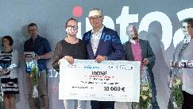
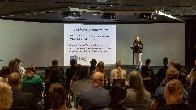
GC Europe N.V.
Interleuvenlaan 33
3001 Leuven
Fon +32.16.74.10.00
Fax +32.16.74.11.99
www.gceurope.com
marketing@gc.dental

