Press Release

GC’s Chairman Mr. Makoto Nakao visits the University of Leuven

20 years of Toshio Nakao Chair for Adhesive Dentistry at BIOMAT, KU Leuven

With GC’s commitment to quality at heart, we consistently focus our efforts towards the customer’s needs. That is why next to our own research and development, we also invest in independent research. The Toshio Nakao Chair for adhesive dentistry is one of those initiatives which has been established to enhance the further development of dental biomaterials for improved clinical performance. For its 20th anniversary, Mr. Makoto Nakao brought a visit to the BIOMAT laboratory and MTM, research entities at KU Leuven.

The Toshio Nakao Chair was established 20 years ago, arising from a mutual interest in adhesive dentistry between GC and BIOMAT, KU Leuven. Since then, the Toshio Nakao Chair has provided continuity of the dental research at KU Leuven in the long term. It has allowed the BIOMAT laboratory to hire researchers for a longer service period and to purchase major research equipment. In those 20 years, the BIOMAT laboratory as developed towards a self-sustaining research environment that closely collaborates with other major research entities, among which the Department of Materials Engineering (MTM). From this collaboration, important concepts such as the AD-concept in tooth-resin interfaces^{1,2} have emerged, which are still valid and at the core of adhesive technology today. Long-term clinical studies with our adhesives and composites are also conducted here, which are indispensable for GC as this feedback is necessary to maintain a high quality and keep working on continuous improvement.

Mr. Nakao visited the research facilities in the presence of the current and first chairholder, Prof. Bart Van Meerbeek and Prof. Em. Guido Vanherle. Some of the new research topics had been presented, including cytotoxicity and genotoxicity studies, long-term clinical studies with G-BOND, everX Posterior and G-ænial and 3D printing of ceramics and titanium. It was a satisfying opportunity for information exchange and deepening mutual understanding, highly valued by all attendees.
GC would like to grab this opportunity to thank all the BIOMAT associates for this fruitful collaboration and we are looking forward to new prospects!
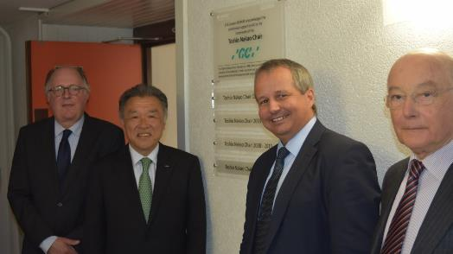

1. Yoshida, Y. et al. Evidence of chemical bonding at biomaterial-hard tissue interfaces. J. Dent. Res. 79, 709–714 (2000).
2. Yoshida, Y. et al. Adhesion to and decalcification of hydroxyapatite by carboxylic acids. J. Dent. Res. 80, 1565–1569 (2001).

GC Europe N.V.
Interleuvenlaan 33
3001 Leuven
Fon +32.16.74.10.00
Fax +32.16.74.11.99
www.gceurope.com
marketing@gc.dental

