Press release

New opportunity for oral health research funding

Foundation Nakao for Worldwide Oral Health to launch new round of research grant applications on 21 September 2021

Dental academics and clinicians are invited to apply for Foundation Nakao Grant from 21 September 2021. This is the third round of funding made available by the prestigious foundation, since its launch in 2018. The organization supports clinical trials and research in important topics such as minimum intervention dentistry and oral health of the elderly.

Successful applications will receive fully funded projects of CHF 50,000.00/per year in addition to wide exposure among dental professionals, dental industry as well as the general public of each study’s outcomes and achievements. (Max 2 years and up to CHF 100,0000. If the project budget is over CHF 50,000 in two years, the applicant needs to submit applications for the second year as well)

Advancing oral health research
The foundation’s Second round of grant applications took place in September 2020 and seven studies were awarded the honor of being accepted out of a huge number of submissions. Applicants represent the following categories: government organization, non-government organization, university, research institution or other.

Foundation Nakao supports academic research and clinical studies contributing to its founding goal, which is the improvement of oral health and subsequent raised quality of life of all people in the world. Key oral health research areas that address Minimum Intervention Dentistry, Oral Health in Ageing Populations and the 8020 movement, Tooth Function, the prevention of Oral Frailty and Dental IQ.

“The inspiration for the Foundation came from a topic that is very close to our hearts: the impact of oral health on quality of life. My husband and I believe that dentistry has a fundamental role to play in the health and longevity of people around the world. We look forward to seeing this becoming a reality through the activities of the Foundation,” said Makiko Nakao, President of Foundation Nakao for Worldwide Oral Health at its official launch in 2018.

About the Nakao Foundation
On Sept 21st, 2018, Foundation Nakao for Worldwide Oral Health was established in Luzern, Switzerland. This was made possible by Mr. Makoto Nakao, former Chairman of GC Corporation, who after 42 years at the helm of the company donated his privately-owned company shares to support this noble initiative.
The management board of Foundation Nakao boasts a team of distinguished dental professionals from four continents; Europe, America, Australia and Asia. They are Professor Reinhart Hickel, Professor Clark Stanford, Professor Macro Ferrari, Professor Eric Reynolds, Professor Keiichi Sasaki and Dr Kiyotaka Nakao.

Application will be open until 24 November 2021 via the application form on the Nakao Foundation website https://www.foundation-nakao.com/applications

For references and more information, please visit:
Foundation Nakao for Worldwide Oral Health
Fluhmattweg 13
6004 Luzern, Switzerland
Fon + 41.41.203.27.17
www.foundation-nakao.com
info@foundation-nakao.com

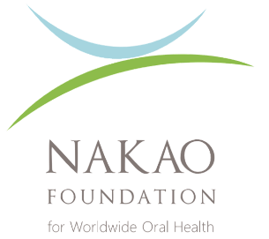

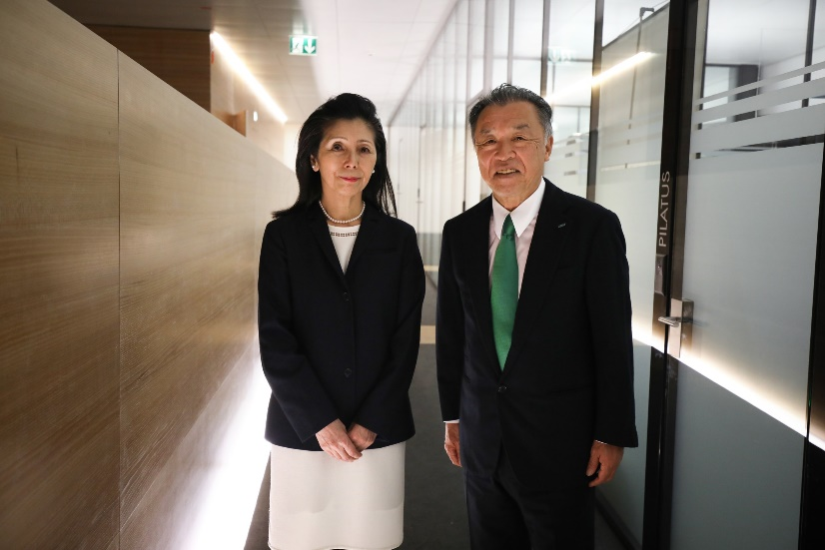
Mrs. Makiko Nakao, President of the Foundation Board and Mr. Makoto Nakao

