Tokyo Medical and Dental University and GC Corporation Signed Comprehensive Partnership Agreement

~Contributing to extending the healthy life expectancy through oral health care by state-of-the art research and clinical knowledge~

National University Corporation Tokyo Medical and Dental University (TMDU) and GC Corporation signed a comprehensive collaborative agreement on 9th June, 2022, based on “TMDU’s Open Innovation Program*.”
*TMDU-industry collaboration program to build an "organization” to “organization” collaboration framework with a shared vision, purpose, and strategy, aiming at realizing a full-scale and comprehensive collaboration.
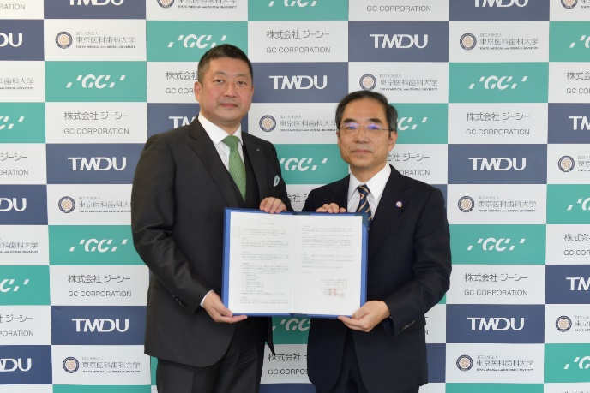

From right: President Yujiro Tanaka, Tokyo Medical and Dental University
/ President and CEO Kiyotaka Nakao, GC Corporation

[Agreement Detail]
- The goal of the collaboration is to extend the healthy life expectancy by promoting the whole-body health through maintenance and improvement of oral functions. To achieve our goal, we will promote the development of the regenerative dentistry including periodontal treatments, and examination for the maintenance and improvement of oral functions, which leads to the provision of information and the creation of products with high clinical value.
- A clinical laboratory will be established at the Center for Advanced Interdisciplinary Dentistry, Tokyo Medical and Dental University Hospital, to achieve clinically valuable ideas and promote the social implementation from research outputs.
- As a demonstration of the presence of this Comprehensive Collaborative Agreement, a naming rights deal has been signed for the clinical lab. Hence, the lab is named “GC CLINICAL LABORATORY.”

Collaborative Research
- Dental restorative material development
- New periodontal treatment research
- Oral regeneration and reconstruction research
- Oral function examination research
Comprehensive Collaborative Agreement
Establishment of Clinical Laboratory
A clinical laboratory is established at the Center for Advanced Interdisciplinary Dentistry, Tokyo Medical and Dental University Hospital
Naming Rights
GC CLINICAL LABORATORY

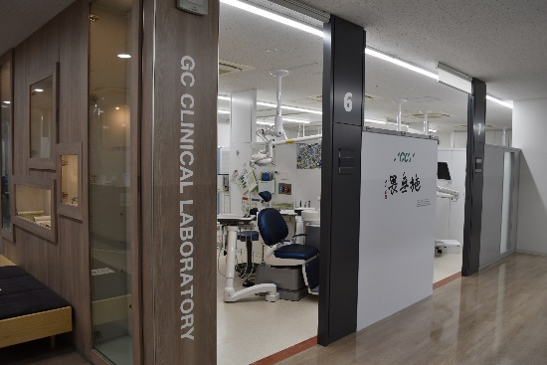

GC CLINICAL LABORATORY established at the Center for
Advanced Interdisciplinary Dentistry, Tokyo Medical and Dental University Hospital

Tokyo Medical and Dental University is a national university and the only comprehensive medical university and graduate school in Japan that has both a Faculty of Medicine and a Faculty of Dentistry. In December 2018, the Institute of Open Innovation was established to accelerate an industry-academia collaboration between "organization" and "organization”. The aim of this institution is to create groundbreaking medical and health innovations with university's strengths in research, medical knowledge, and clinical practices at the University Hospital, where the medical and dental fields are connected.

[Expectation for Comprehensive Partnership]
This Comprehensive Collaborative Agreement will promote collaboration with overseas research facilities such as the University of Zurich by making the most of our international network, which will also support researchers through exchanges and promote international valuable research from a global perspective. Through these efforts, GC aims to develop new products, expand the business, and play a more significant role in supporting the QOL (Quality of Life) of people worldwide and improve "a zest for life."
GC Corporation celebrated its 100th anniversary on 11th February, 2021, and announced the new Vision 2031 “To become the leading dental company committed to realizing a healthy and long-living society”. GC group will continue united efforts to realize this Vision, contributing to health and smile of the people around the world. We look forward to your continued support going forward.

