Press release

Announcement on Succession of Collagen Business of Olympus Terumo Biomaterials Corporation through Company Split (Absorption-Type Company Split)

GC Corporation would like to announce that it has agreed with Olympus Terumo Biomaterials Corporation (hereinafter referred to as "OTB") to succeed those businesses of the development, manufacturing and sales of such biomaterials as Teruplug (protective material for extraction wounds primarily for dentistry), Terudermis (graft for dermal defects primarily for plastic surgery and emergency medical treatment), etc. as well as the dental product sales business which OTB handles in the collagen business etc. through an absorption-type company split with the aim of further enhancement of the businesses of OTB and GC.
GC has strengthened the development and sales of biomaterials, such as GC Implants, Cytrans Granules (resorbable bone graft substitute) and Cytrans Elashield (resorbable bilayer membrane). GC is confident that the field of periodontal tissue regeneration therapy will take on a greater degree of importance than ever in the years ahead, and therefore adding the biomaterials owned by the collagen business etc. of OTB to the product lineup of GC will enhance GC’s product structure and create a synergy through the sales networks of both companies. Additionally, deepening the knowledge and expertise of GC’s biomaterial business through its efforts in the medical field will further strengthen the biomaterial business of GC in both dental and medical fields, which has led to the decision of this business succession.
GC is dedicated to continuing further efforts towards globalizing its business and proactively working to address the needs of customers around the world in the biomaterial field.
GC has announced its Vision 2031: “To become the leading dental company committed to realizing a healthy and long-living society.’ With determination, GC endeavors to further meet this goal. Your continued inspiration and support towards this goal is most appreciated.

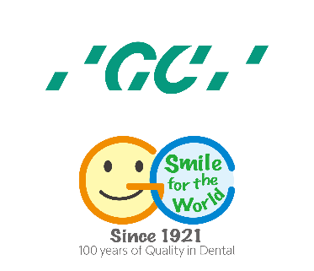

GC Europe N.V.
Interleuvenlaan 33
3001 Leuven
+32.16.74.10.00
https://www.gc.dental/europe
info.gce@gc.dental

