Press release, April 2023

The 11th Quality Management Level Research 2022 – Awarding Ceremony and Memorial Lecture were held.

GC was awarded “5 stars,” the highest rating possible, in the 11th Quality Management Level Research awards, which was organized by the Union of Japanese Scientists and Engineers (JUSE) and sponsored by Nikkei Inc., the Japan Chamber of Commerce and Industry, and the Tokyo Chamber of Commerce and Industry, featuring research and analysis by Nikkei Research Inc. The Memorial Lecture and panel discussion were held at JUSE Higashi-Koenji Building and livestreamed on March 22, 2023.

This quality management research is conducted with the aim of encouraging companies, not only to promote quality management, but also to raise awareness within the industry about the importance of “quality.” Previously, through 2018, the results of the evaluation were presented as a ranked list, which was replaced by a star-rating system in 2022.

Quality Management Level Research rates companies across the following six categories:
- Ensuring the Trust of Customers and Society
- Top Management Commitment and Policy Management
- Cultivation of Human Resources for Realization of Quality Management
- Establishment and Thorough Implementation of a Process
- Creation of Customer Value and its Expansion
- Capability to Deploy a System Horizontally

Because of excellence across all six facets, GC was awarded the highest rating of “5 stars,” an impressive follow-up from GC’s 2nd place ranking in 2018 and exemplifies the company’s continued dedication to quality.

In his speech titled “GQM – GC’s Quality Management – Efforts to Strengthen Quality Management Across GC Group,” Hidetoshi Funabashi, Director of Quality Assurance and GQM Promotion, introduced our “global focus activities to strengthen quality management,” “recent efforts concerning corporate quality,” and “future activities” in respect of three elements of the company: “Nakama,” “system,” and “culture.”

During the panel discussion, the panelists of other awardee companies participated in a lively exchange of opinions regarding the questions raised by the members of the Quality Management Level Research Committee and the participants, such as how to extend and utilize VOC (Voice of Customer) across the company and compliance activities.

【Speakers of the Memorial Lecture by 5-star companies】
Suntory Holdings Ltd.
GC Corporation
Ricoh Company, Ltd.
*In the order of presentation
Through relentless promotion of GC’s Quality Management (GQM), GC continues to increase company-wide efforts regarding quality management and fulfillment of customer expectations. Your continued support is greatly appreciated.
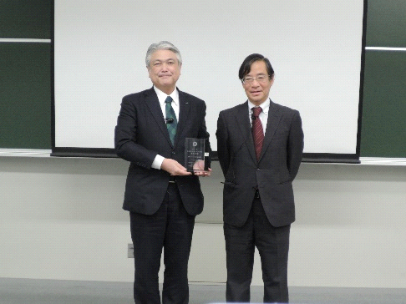
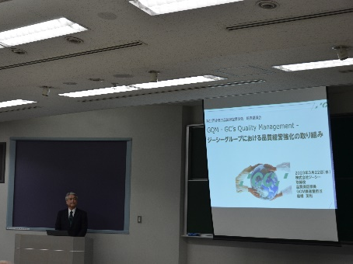
Awarded as a “5 star” company

Memorial Lecture

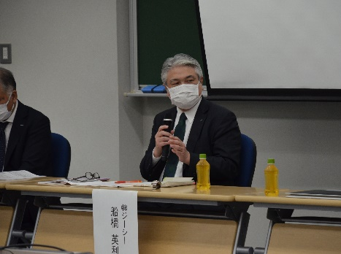

Panel discussion

GC Europe N.V.
Interleuvenlaan 33
3001 Leuven, Belgium
Phone +32.16.74.10.00
https://www.gc.dental/europe/
marketing.gce@gc.dental

