Press release

And the winner is…

4th edition of the Essentia Academic Excellence Contest

On 15 & 16 of September 2023, the international final of the Essentia Academic Excellence Contest took place at the Training and Education Centre of GC Europe.

With the overall level being exceptionally high, it was a tough call for the international jury - Javier Tapia Guadix (Spain), Alain Perceval (Belgium), Adriano Teixeira (Brazil) and Laetitia Lavoix (France) – who selected the winners:

- Undergraduate, 1st Prize Winner: Bilal Balbzioui; France
- Undergraduate, 2nd Prize Winner: Simeona Olić; Croatia
- Post-graduate, 1st Prize Winner: Bianca Varvara ; Romania
- Post-graduate, 2nd Prize Winner: Χαρά Καράγιωργα (Chara Karagiorga); Greece
- Facebook winner: Khansaa Elmokkadem; Morocco

“Presenting my case in English was a real challenge, rewarded with two days of fantastic exchanges and a master course of Dr Javier Tapia Guadix,” said Dr Lisa Belrepayre, one of the finalists. “It has been a real gift and I feel proud that I could take part in this international event.”
“I was honestly amazed by the deep motivation and high level of work by all contestants,” stated Kerstin Behle, EMEA Professional Services Manager at GC Europe. “There was a pleasant vibe among all participants, and it was clear that the students as well as their tutors were keen on expanding their network, exchanging experiences, ideas and much more.”
This fourth edition was also the last one of the Essentia Academic Excellence Contest.
This doesn’t mean the search for excellence will stop. Next year, GC Europe will take it one step beyond with the G-ænial A’CHORD contest, which will be announced soon. Despite its universality, this simplified shade system can handle extreme challenges, and we’re looking forward to seeing these from a new group of contestants, hopefully as talented and motivated as the ones we had the pleasure to have with us this year.

GC Europe N.V.
Interleuvenlaan 33
3001 Leuven
+32.16.74.10.00
https://www.gc.dental/europe
info.gce@gc.dental

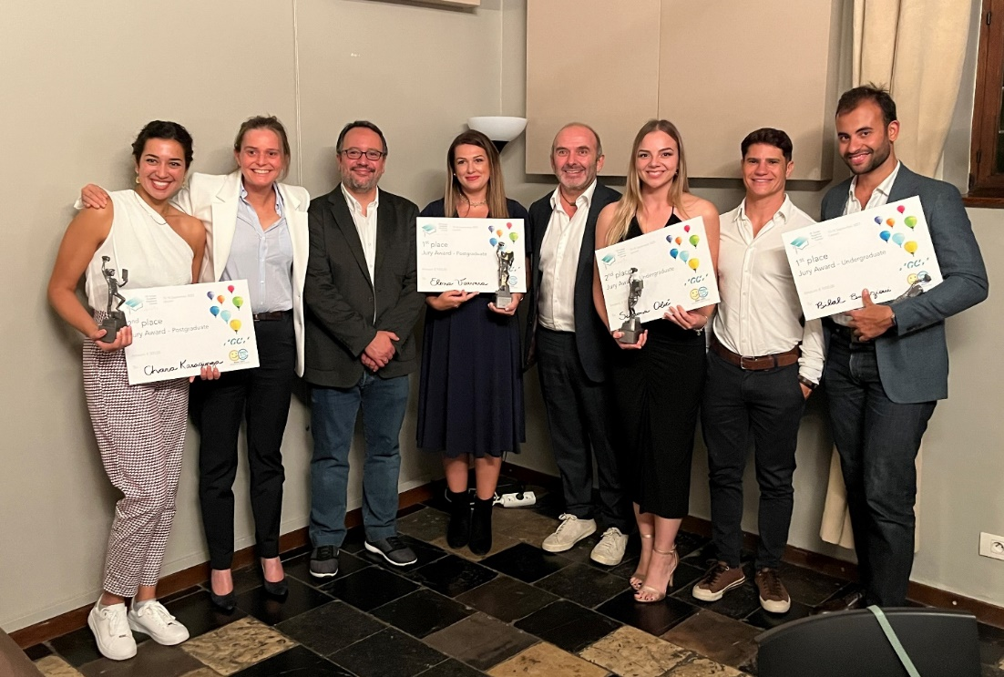
From left to right : Chara Karagiorga (Χαρά Καράγιωργα), Laetitia Lavoix, Javier Tapia Guadix, Bianca Varvara, Alain Perceval, Simeona Olić, Adriano Teixeira, Bilal Balbzioui

