Press release

GC Academic Excellence Contest 2024

Winners Announced for the 2024 GC Academic Excellence Contest

Leuven, September 2024 - GC Europe is thrilled to announce the winners of the 2024 GC Academic Excellence Contest, which drew 272 participants from over 70 universities across more than 20 countries. This prestigious competition, designed to promote innovation, academic excellence, and hands-on experience with GC Europe's leading dental products, offers participants a unique opportunity to showcase their talents while deepening their practical knowledge.

After national competitions in the participating countries, the top finalists were invited for a two-day stay in Leuven, Belgium, where they presented their work before an esteemed panel of experts and attended a Master Course by Dr Javier Tapia Guadix at GC Europe’s state-of-the-art Campus and Education Centre. All participants enjoyed this unique chance to network with fellow professionals and expand their academic and practical horizons.

In the Undergraduate category, Cristina Neghina from Romania claimed first prize, with Nayera Amr Nazmy from Egypt in second place. For Postgraduates, Maria Fostiropoulou from Greece took first, and Marwa Abdel Hafez from Egypt came second.

Public awards went to Mostafa Elmisky from Egypt for Facebook, while Irem Öskurt from Turkey won on Instagram.

Congratulations to all the winners and a heartfelt thank you to everyone who contributed to this year’s success! Your efforts continue to raise the bar for academic and clinical excellence in the dental field!

GC’s Academic Excellence Contest enjoys an esteemed reputation, with a broad and diverse following from top universities. Next to the monetary award for the winners, participating institutions appreciate the gained exposure, adding to the visibility and recognition within the academic and professional communities. The next edition is scheduled to take place on 19 and 20 September 2025.

GC Europe N.V.
Interleuvenlaan 33
3001 Leuven
+32.16.74.10.00
https://www.gc.dental/europe
info.gce@gc.dental
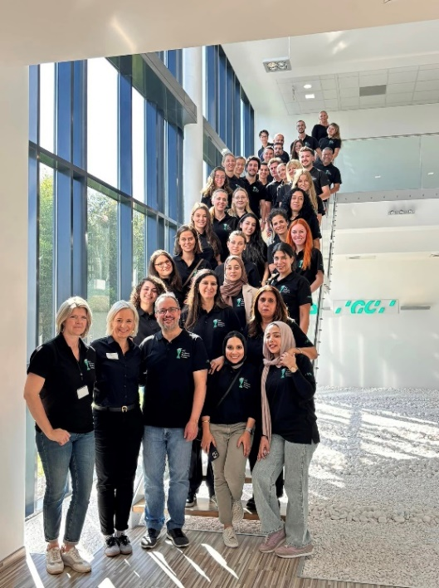
The jury, participants and GC hosts at the GC Europe Campus
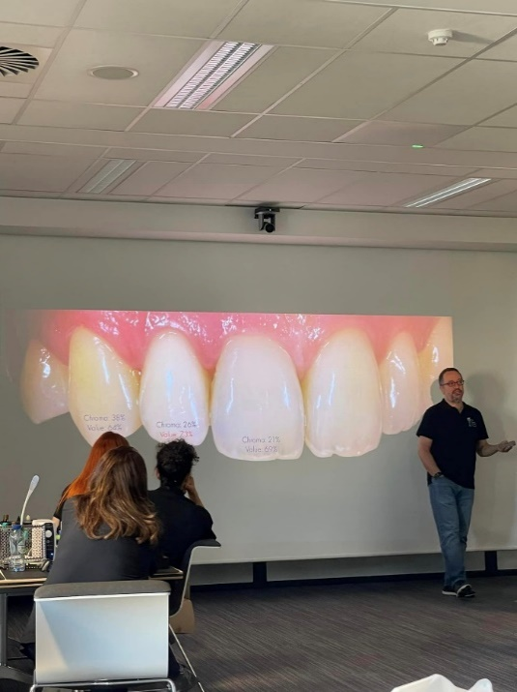
Master Class by Javier Tapia Guadix
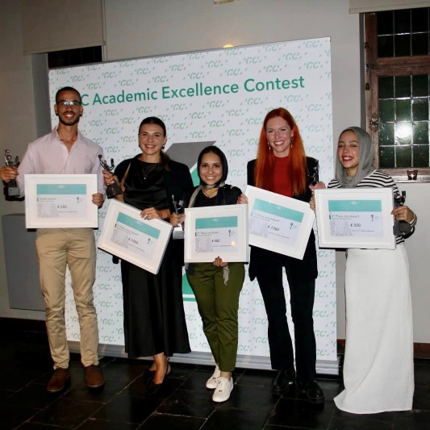
Anouncement of the winners at Faculty Club, Leuven. From left to right : Mostafa Elmisky, Cristina Neghina, Nayera Amr Nazmy, Maria Fostiropoulou, Marwa Abdel Hafez. Not pictured: Irem Öskurt.

