Press release

6th GC Academic Excellence Contest 2025

European Final Highlights Top Talent and Collaboration

Leuven, September 2025 - GC Europe is thrilled to announce the winners of the 2025 GC Academic Excellence Contest. This coveted competition, drew 150 participants from over 60 universities across more than 20 countries.

The first day was filled with inspiring presentations, each reflecting the hard work, enthusiasm and creativity of the participants undergraduate participants employed the cusp-by-cusp technique, while postgraduate entrants addressed aesthetic challenges using the injection moulding method. After careful deliberation by our esteemed jury members Javier Tapia Guadix, Alain Perceval, Simone Moretto and Laetitia Lavoix, the winners were announced across two categories:

Junior (Undergraduate) Category
1st Place: Mostafa Ahmed Hany (New Giza University Cairo, Egypt)
2nd Place: Aude Quillet (Université Libre de Bruxelles, Belgium)

Senior (Postgraduate) Category
1st Place: Linda Panbachi (Katholieke Universiteit Leuven, Belgium)
2nd Place: Annamaria Forte (University of Bologna, Italy)

In addition, People's Choice Awards were conferred based on the highest number of likes received on the contest’s official social media platforms:
Social Media Winners
Facebook: Abdelrahman Mohamed Abdelalim (Egyptian Russian University, Egypt)
Instagram: Ayatellah Mohamed Ossman (Cairo University, Egypt)

The overall quality of submissions was truly exceptional, and each finalist contributed to an inspiring and memorable event.
The celebration continued the second day with a full-day masterclass led by Javier Tapia Guadix, offering students and tutors valuable insights and hands-on learning for composite layering and Class IV restorations. The session was highly appreciated and added a rich educational dimension to the weekend.

It was an intense but rewarding two-day experience, filled with enthusiasm, collaboration, and a fantastic atmosphere.

GC’s Academic Excellence Contest enjoys an esteemed reputation, with a broad and diverse following from top universities. Next to the monetary award for the winners, participating institutions appreciate the gained exposure, adding to the visibility and recognition within the academic and professional communities.
Stay tuned for updates on the next edition in 2026! If you are interested to join, please feel free to check our website or social media groups for updates, or to reach out to your local GC contact.

GC Europe N.V.
Interleuvenlaan 33
3001 Leuven
+32.16.74.10.00
https://www.gc.dental/europe
info.gce@gc.dental

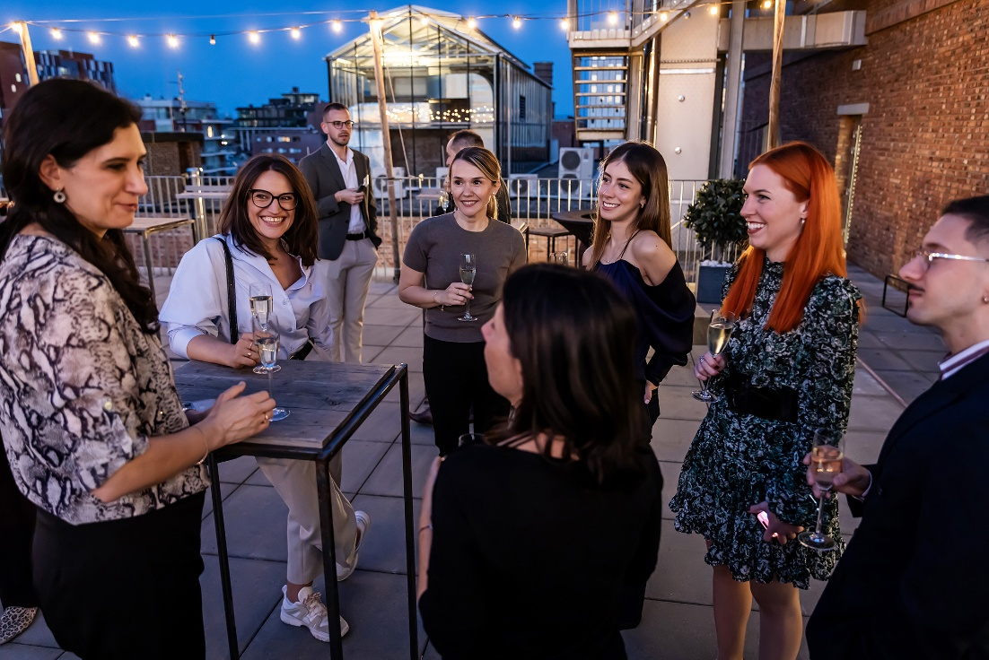
The winners were announced at the award ceremony at ‘De Hoorn’, an ancient brewery transformed to a fascinating event location.
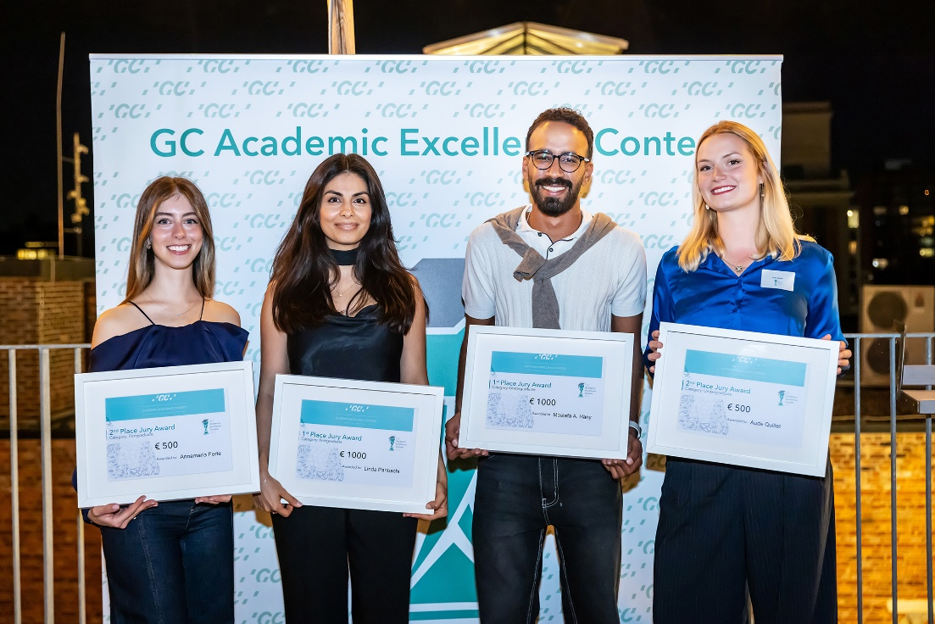
The Academic Excellence laureates. From left to right: Annamaria Forte, Linda Panbachi, Mostafa A. Hany, Aude Quillet.
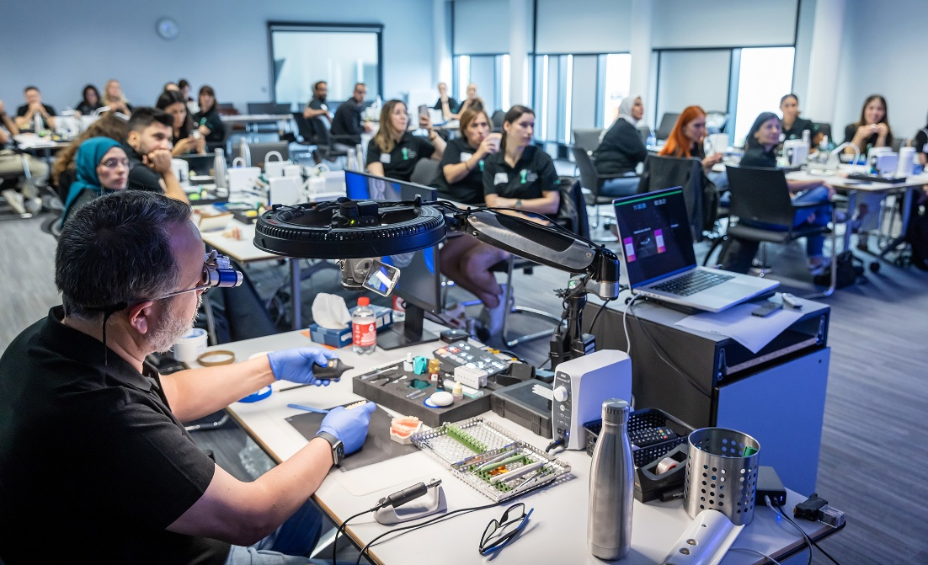
Masterclass led by Javier Tapia Guadix.

