Press release

GC Europe Supports Oral Health Education Initiative in Tanzania

International partnership empowers local professionals to improve oral health for 115,000+ children

Leuven, Belgium / Mwanza, Tanzania – July 2026 – GC Europe has joined forces with Tanzanian health organisation THEDI, the UK oral health charity Bridge2Aid, Colgate-Palmolive Tanzania and local government authorities to deliver a community oral health education programme in Tanzania across the Sengerema District.
The programme is expected to reach approximately 115,000 schoolchildren, while also benefiting thousands of families through oral health messages shared in schools, healthcare facilities and local communities.
Sengerema District is home to around 500,000 people and is served by only two dentists and three dental therapists, making preventive education particularly important.
A key strength of the initiative was its focus on local leadership. Training was delivered primarily by Tanzanian District Dental Officers, THEDI representatives and dental therapists who had previously participated in professional development programmes supported by Bridge2Aid. As part of the initiative, seven GC Europe Nakama travelled to Mwanza and Sengerema to support training programmes and practical workshops focused on prevention, education and community engagement.
The programme brought together representatives from 60 schools and 44 villages.
GC Europe distributed toothbrushes donated by dealer partners BASIC DENTAL, Dental Union, DHB Dental Health Boutique, Henry Schein Dental BeLux, and Tandwinkel.nl to participating schools and villages, equipping children and families with practical resources to maintain healthy daily habits.
Efforts to prevent Infant Oral Mutilation (IOM), a harmful traditional practice involving the removal of developing tooth buds in young children, were also addressed. Discussions with local experts highlighted the important role of education and community engagement in protecting children's health and challenging harmful beliefs.
Katrin Langer, Vice President of Sales at GC Europe, said: “Working with dental professionals who want to help their communities improve oral health is inspiring. We came as strangers and left as allies in the fight against Infant Oral Mutilation.”
John Maloney, Country Manager at GC UK, added:
“What stood out to me was the strength of the local leadership and the commitment of everyone taking part. This was about equipping people who are trusted within their schools and communities to create lasting change. Seeing participants put their plans into action before the programme had even finished showed the real impact of the partnership.”
Through partnerships such as this, GC Europe continues its commitment to improving oral health worldwide by supporting education, prevention and sustainable community-led initiatives that create lasting impact.

GC Europe N.V.
Interleuvenlaan 33
3001 Leuven
+32.16.74.10.00
https://www.gc.dental/europe
info.gce@gc.dental

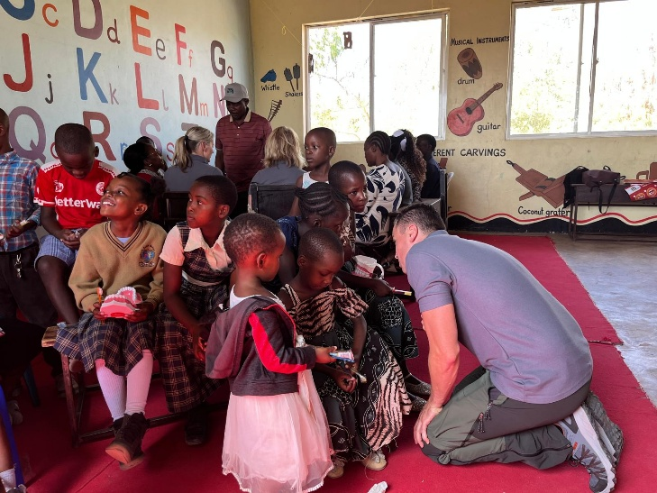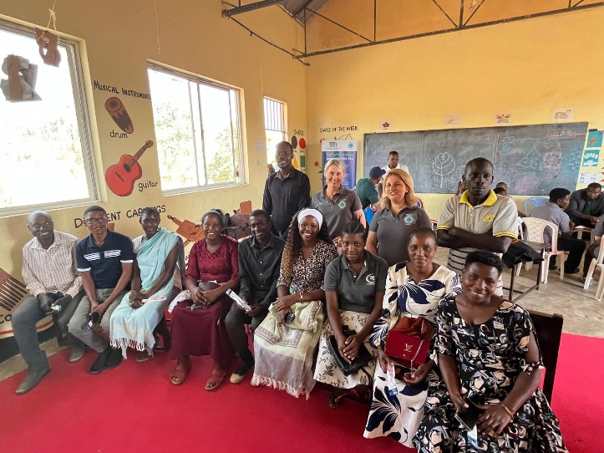
GC volunteers supported training programmes and workshops on prevention in oral health.

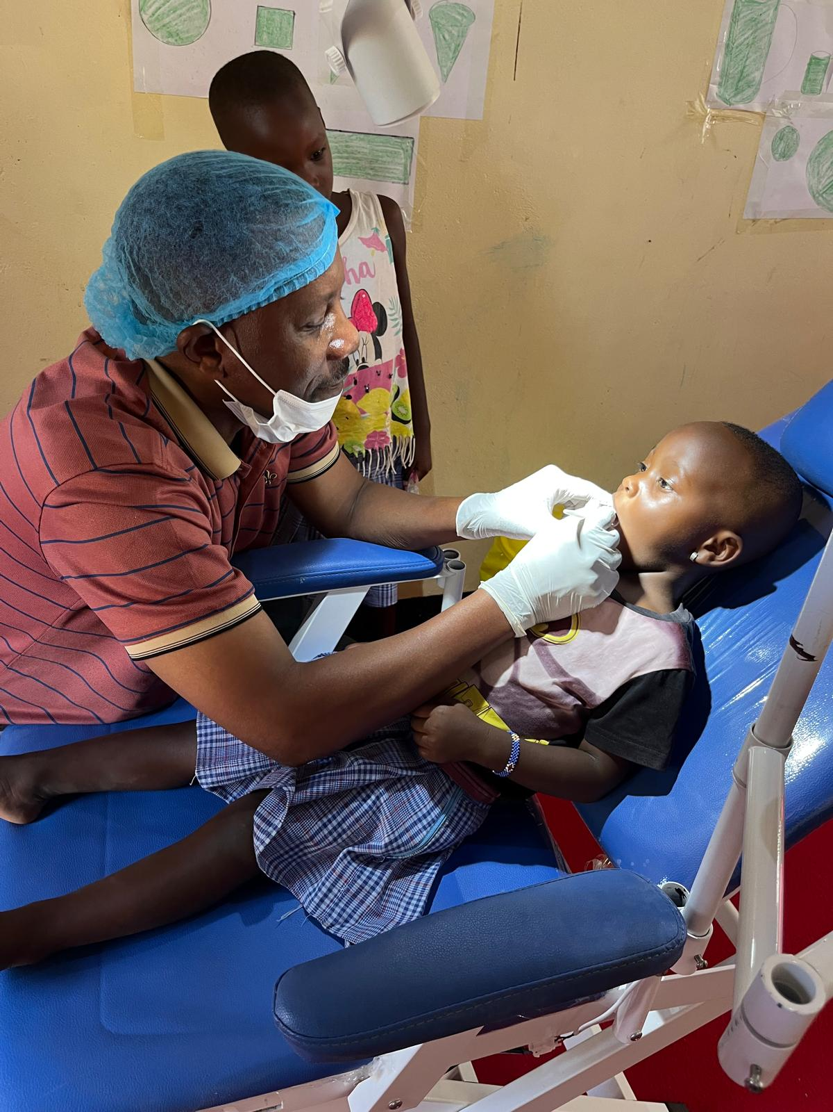
Many people in Tanzania—especially in rural areas—have limited access to dental care due to shortages of trained professionals and resources. Combined with low awareness of proper oral hygiene practices, this contributes to high rates of tooth decay and gum disease.

