Press release

Extension ‘Toshio Nakao Chair’

KU Leuven and GC Europe renew the Toshio Nakao Chair for a sixth term, reinforcing a unique partnership in dental research

LEUVEN, Belgium, 23 June 2026 – KU Leuven and GC Europe have officially inaugurated the latest extension of the Toshio Nakao Chair for Adhesive Dentistry, marking the sixth consecutive term of a partnership that has become a benchmark for long-term collaboration between academia and industry. The chair, held by Professor Bart Van Meerbeek within the BIOMAT research group of KU Leuven's Group of Biomedical Sciences, is the oldest endowed chair at KU Leuven and a powerful symbol of mutual trust, shared ambition and scientific excellence.
Established in 1998 through the support of GC, the Toshio Nakao Chair was created to advance research on adhesive materials and their interaction with tooth structure, contributing to the development of innovative dental materials and techniques in the field of adhesive dentistry. For nearly three decades, the collaboration has fostered scientific discoveries with direct relevance for dental practitioners and patients worldwide.
The inauguration ceremony took place on 23 June 2026 in the Rectoral Salons of KU Leuven. The programme opened with a welcome by Gert-Jan Bakx of KU Leuven's Fundraising and Alumni Relations Office, followed by addresses from Professor Bart Van Meerbeek and Dr. Per Falk, CEO of GC International. The ceremony included the signing of the contracts, an acknowledgement by Rector Séverine Vermeire, and the exchange of commemorative gifts between donor and chairholder.
For both partners, the renewal represents much more than the continuation of a successful funding initiative. It highlights a longstanding relationship built on confidence, continuity and a shared commitment to bring value in dental care to realise a healthy long-living society.
"The success of this partnership is built on a shared respect for scientific independence," said Professor Bart Van Meerbeek. "Throughout the years, GC has consistently supported objective research, even when results did not necessarily align with initial expectations."
The renewed chair covers the period 2026–2030, representing the fifth extension since its foundation. Such continuity is exceptional and underscores the strategic value both partners place on sustained research collaboration.
Dr. Per Falk, CEO of GC International, emphasized the importance of investing in long-term scientific partnerships. " Since its foundation, GC has recognised that innovation begins with listening. By staying close to our customers and working hand in hand with researchers, we gain the insights needed to continuously improve our materials and contribute to better oral healthcare worldwide."
The chair's focus on adhesive dentistry aligns perfectly with the mission of the BIOMAT research group, internationally recognised for its pioneering work on dental biomaterials. By supporting translational research, the collaboration helps bridge the gap between laboratory discoveries and clinical practice, ensuring that scientific advances can ultimately benefit dentists and patients alike.
In her acknowledgement, Rector Séverine Vermeire praised the enduring partnership as an example of how universities and industry can work together to create lasting societal impact through research, innovation and knowledge transfer.
As KU Leuven and GC Europe look ahead to the next five years, the renewed Toshio Nakao Chair reaffirms their shared ambition to advance the frontiers of adhesive dentistry and to continue translating scientific excellence into tangible benefits for oral healthcare worldwide.

GC Europe N.V.
Interleuvenlaan 33
3001 Leuven
+32.16.74.10.00
https://www.gc.dental/europe
info.gce@gc.dental
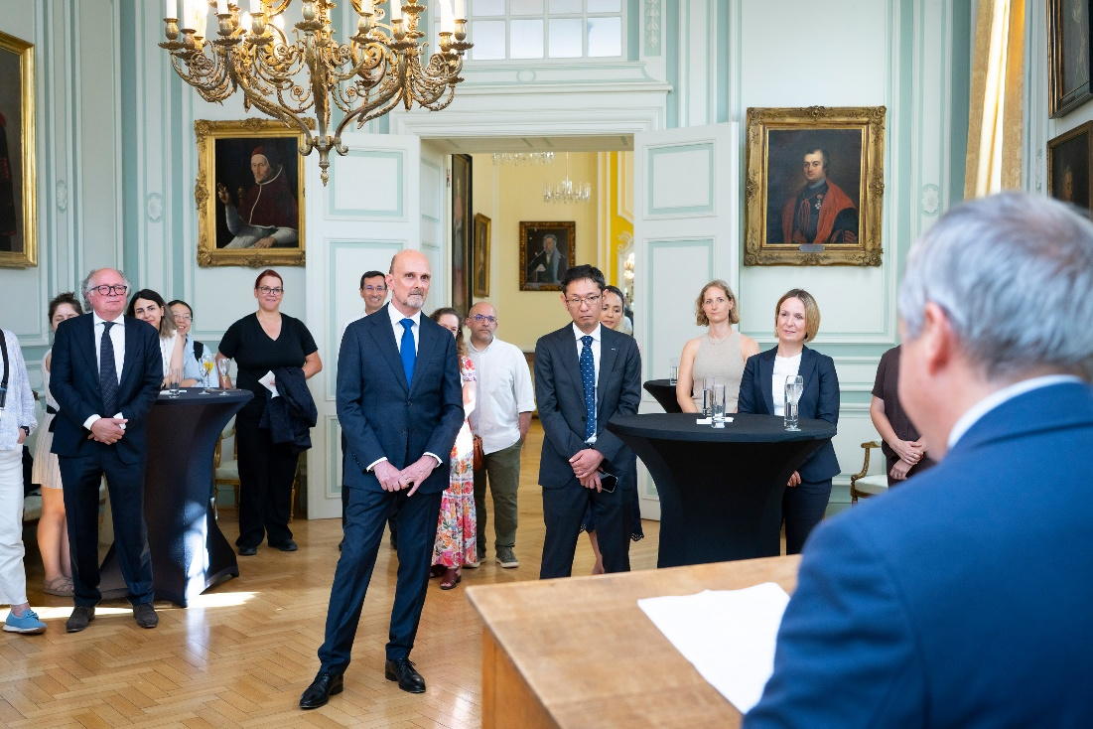
Prof. Bart Van Meerbeek highlighted how almost three decades of collaboration between KU Leuven and GC have successfully bridged independent scientific research and industrial innovation.
Copyright: KU Leuven - Michael De Lausnay

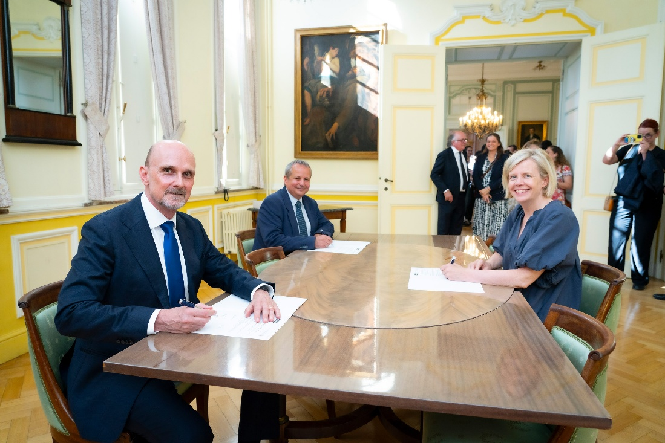
Signing of the prolongation of the Toshio Nakao Chair. From left to right: Dr. Per Falk, CEO of GC International AG, Prof. Bart Van Meerbeek, Chairholder and head of KU Leuven’s BIOMAT Research Group of the Department of Oral Health Sciences, and Prof. Severine Vermeire, Rector of KU Leuven.
Copyright: KU Leuven - Michael De Lausnay

