PRESS RELEASE


To Members of the Press
October 6, 2026
GC Corporation
No20260003
Dental Professionals from 71 Countries and Regions Gather
70th Anniversary of the GC Membership Society: THE 6th INTERNATIONAL DENTAL SYMPOSIUM Held
—Latest Insights in Dental Care Shared Across 65 Sessions Featuring 204 Speakers—

GC Corporation (Bunkyo-ku, Tokyo), a comprehensive dental products manufacturer, hosted the 70th Anniversary of the GC Membership Society: THE 6th INTERNATIONAL DENTAL SYMPOSIUM at the Tokyo International Forum (Chiyoda-ku, Tokyo) on Saturday, October 3 and Sunday, October 4, 2026.
Held under the theme Gather Knowledge, Create “8 Billion” Smiles!, the symposium welcomed 7,598 registered participants, including 1,764 from overseas, and brought together dental professionals from 71 countries and regions. Across 65 sessions, 204 speakers from around the world presented the latest research findings and clinical insights, followed by lively question-and-answer sessions. The program covered a wide range of fields—including regenerative medicine, digital dentistry, orthodontics, esthetic restorative dentistry, periodontics, endodontics, and preventive dentistry—as well as the relationship between oral and systemic health, with sessions on oral function, nutrition, and sleep. The symposium provided researchers and clinicians from Japan and abroad with an opportunity to exchange the latest knowledge.
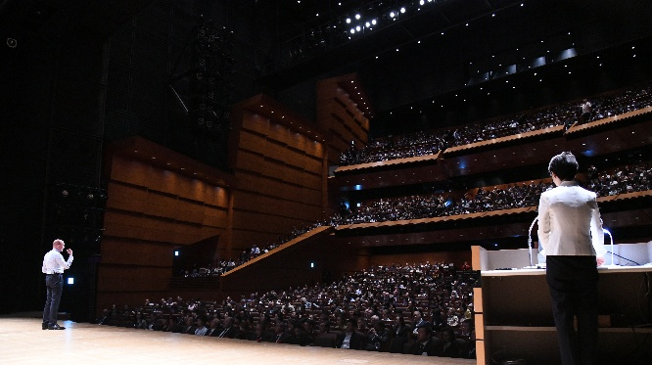
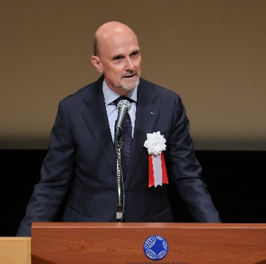
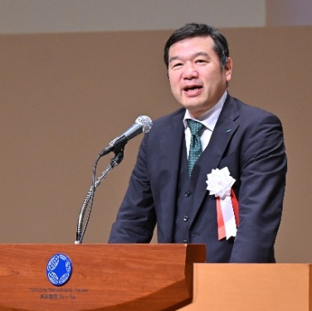
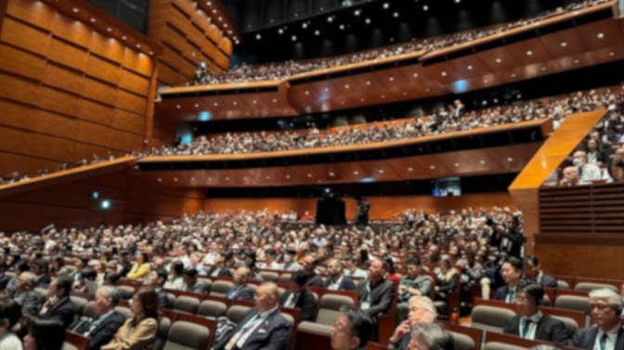

Dr. Per Falk Yutaka Shinozaki Opening Ceremony
CEO & Member of the Board President, Representative Executive Officer & Regional COO
GC Holding AG GC Corporation

Bringing Together Knowledge and Expertise from Japan and Around the World
The symposium was held across ten venues at the Tokyo International Forum—including a hall with a capacity of up to 1,500—as well as at satellite venues. Presentations highlighted the latest dental research findings and their clinical applications.
The symposium opened with a program titled “Cutting-Edge Research to Foster 8 Billion Smiles.” The program presented leading-edge research findings, including “New insights into inflammatory bone destruction and bone formation” and “Development of a new antibody drug to treat congenital tooth agenesis.” Presentations on the relationship between oral and systemic health—including dental approaches to sleep apnea and the use of nutrition in lifestyle and dietary guidance—also attracted considerable interest.
The venues were filled with participants, who deepened their knowledge through lectures and question-and-answer sessions while building professional networks across countries, regions, and fields of expertise.

GC Dental Show Held Concurrently
The GC Dental Show was held concurrently at the venue, showcasing the latest dental materials and equipment. GC Group companies and more than 20 partner companies exhibited or sponsored the event, drawing many symposium participants and other visitors to the exhibition area. Hands-on opportunities to explore products and systems allowed visitors to identify potential solutions to clinical challenges and discover new possibilities in dental care. Six seminars, along with preparation and TeC competitions, added to the lively atmosphere.
<Main Special Exhibition Areas>
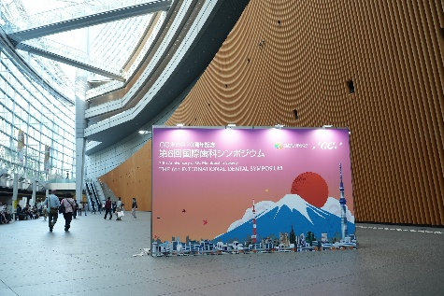
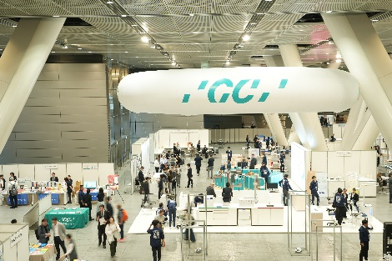
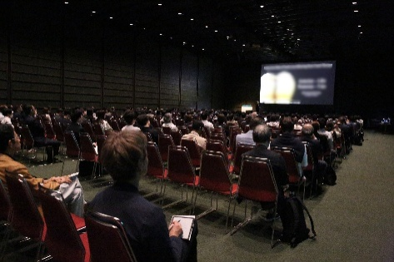
Consultations and hands-on demonstrations of oral function-related products / Preventive care product demonstrations / Large-scale clinical equipment & G-ZONE / Microscope demonstrations / Infection prevention products / KaVo Planmeca demonstrations / Dentsply Sirona demonstrations / Books
(Lecture session) (GC Dental Show) (Tokyo International Forum, the event venue)
Press Conference Held
A press conference for the media was held on Sunday, October 4. The speakers were FDI President Asst. Prof. Dr. Nikolai Sharkov; IADR President Prof. Jennifer Gallagher; Dr. Hideto Takahashi, President of the Japan Dental Association; Ms. Makiko Nakao, President for Worldwide Oral Health; Dr. Per Falk, CEO of GC Holding AG; and Mr. Hiroshi Shinozaki, President, Representative Executive Officer & Regional COO of GC Corporation. Representatives from seven media organizations attended. The speakers unanimously emphasized that oral health is an essential foundation for overall health and healthy longevity.

Promoting International Exchange through “GC Week”
The period from Thursday, October 1 through Thursday, October 8, encompassing the symposium, was designated “GC Week.” GC Corporation is hosting a variety of exchange programs for speakers and dental professionals from Japan and overseas at the GC Corporate Center (Bunkyo-ku, Tokyo). These include nine hands-on seminars led by speakers from Japan and abroad, as well as showroom and factory tours for overseas participants. The programs are designed to deepen understanding of dental care in Japan and the GC Group’s initiatives while encouraging interaction among participants.

Event Overview
Event Name | 70th Anniversary of GC Membership Society THE 6th INTERNATIONAL DENTAL SYMPOSIUM
Main Theme | Gather Knowledge, Create “8 Billion” Smiles!
Dates | October 3 (Sat.)–4 (Sun.), 2026
Venue | Tokyo International Forum (Chiyoda-ku, Tokyo)
Organizer | GC Corporation
Supported by | Japan Dental Association  Japanese Association for Dental Science  Japan Dental Technologists Association  Japan Dental Hygienists’ Association  Tokyo Dental Association  Tokyo Dental Technologists Association  Tokyo Dental Hygienists’ Association  FDI World Dental Federation  IADR (International Association for Dental Research)
Guided by its corporate philosophy “to contribute to global society through the improvement of oral health,” GC Corporation will continue to pursue research and development and provide products, services, and information that advance dental care and help create a society in which people can enjoy longer, healthier lives.
We wish to express our deepest and most sincere appreciation to all those who attended the symposium, to our distinguished guests and speakers, to the exhibiting companies and members of the media, and to the many individuals and organizations whose generous support and invaluable contributions were instrumental in bringing this event to fruition.

