Press release

7th GC Academic Excellence Contest 2026

European Final Celebrates Rising Dental Talent

Leuven, September 2026 - Excellence and innovation were on display at the 7th GC Academic Excellence Contest, which attracted more than 150 participants from over 60 universities across 25 countries.
Following several rounds of evaluation, outstanding undergraduate and postgraduate students advanced to the European Final, where they presented their work before an international jury comprising Javier Tapia Guadix, Prof. Marleen Peumans, Dr Simone Moretto, Dr Alain Perceval and Laetitia Lavoix. The 14 finalists impressed with a high level of clinical and technical expertise, demonstrating the cusp-by-cusp technique in the undergraduate category and the injection moulding technique in the postgraduate category. After careful deliberation, the jury selected the following winners:

Senior (Postgraduate) Category
1st Place
Christos Kladouchas, University of Athens, Greece
2nd Place
Diego D'Urso, University of Bologna, Italy

Junior (Undergraduate) Category
1st Place
Romane Sauget, University of Bordeaux, France
2nd Place
Mohamed Hashem, University of Cairo, Egypt

The event also celebrated the enthusiasm of the wider dental community through the People's Choice Awards, recognising the participants who received the greatest support on social media.

Social Media Awards
Facebook
Mario Nader Mories, University of Cairo, Egypt
Instagram
Mustafa Özkan, University of Gaziantep, Türkiye

Beyond the competition itself, the event offered valuable opportunities for learning and networking. Participants and tutors came together for an immersive Master Class led by Javier Tapia Guadix, focusing on composite layering strategies and Class IV restorations. Combining theoretical insights with hands-on training, the session provided attendees with practical techniques that they can apply in their future clinical practice.
What made the weekend particularly memorable was not only the quality of the presentations, but also the atmosphere of collaboration among students, tutors, and experts from different countries and backgrounds. The exchange of ideas, experiences, and clinical approaches highlighted the contest's broader mission of supporting the next generation of dental professionals.

Over the years, the GC Academic Excellence Contest has evolved into a respected international platform that connects leading universities and emerging talent. In addition to the monetary prizes awarded to the winners, participating institutions benefit from increased visibility and recognition within both academic and professional circles.
With another inspiring edition behind us, GC Europe extends its congratulations to all finalists and thanks every participant, tutor, and jury member for contributing to the event's success and already looking forward to the next edition.

Interested in joining the next edition? Follow GC Europe's website and social media channels, or contact your local GC representative for upcoming announcements and participation details.

GC Europe N.V.
Interleuvenlaan 33
3001 Leuven
+32.16.74.10.00
https://www.gc.dental/europe
info.gce@gc.dental

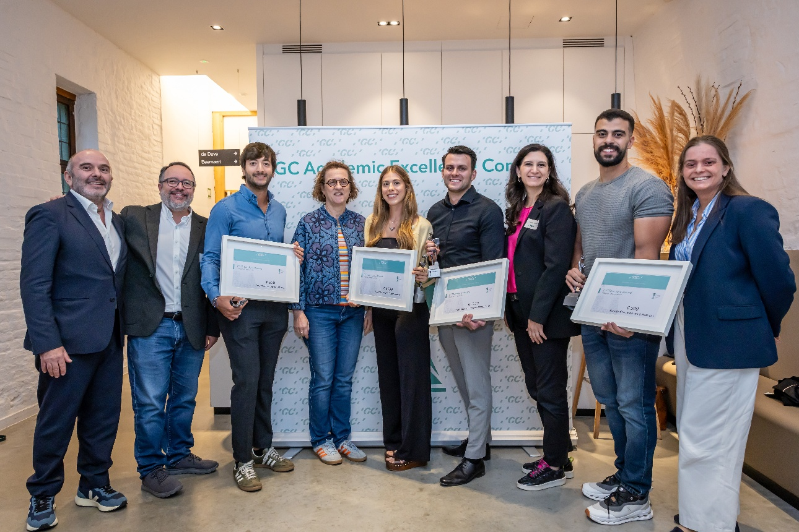
Prize winners and jury members of the 7th GC Academic Excellence Contest. Pictured from left to right are Alain Perceval, Javier Tapia Guadix, Diego D'Urso, Prof. Marleen Peumans, Romane Sauget, Christos Kladouchas, Dr. Simone Moretto, Mohamed Hashem, and Laetitia Lavoix.

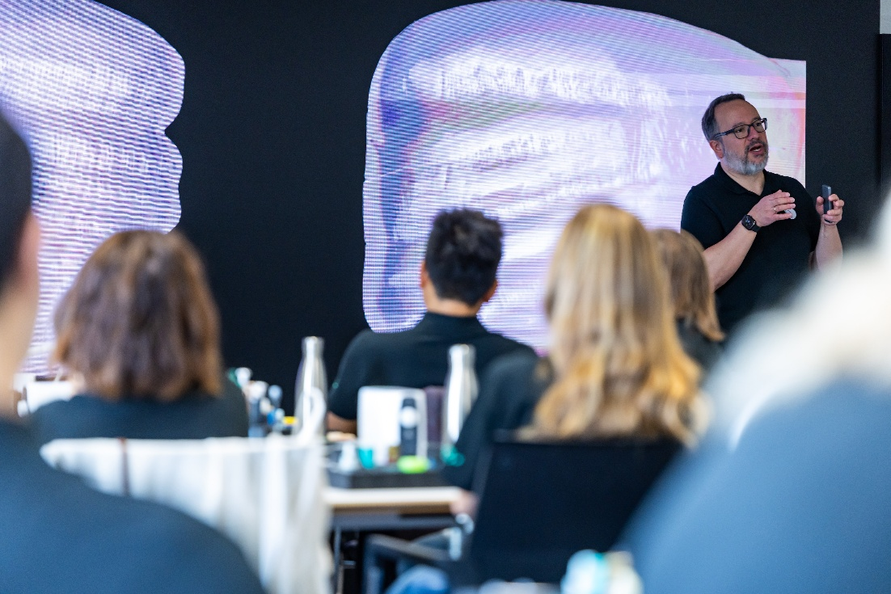
The second day, the participants followed an immersive Master Class, led by Javia Tapia Guadix

